**Relational Database Project -** *Implementation Phase*

***Polaris Recruitment***

**Table of Contents: Page No.**

Tables Printout

Select View 2 - 5

Design View/Create Table Scripts 5 - 8

Database Diagram 9

Queries

Explanation 10

SQL Script 10 - 12

Result 13 - 17

Visual Basic Project

Form Screenshots 18 - 21

Form Code 22 - 25

Test Plan

Test Data Used - Insert Scripts 26 - 28

Modifications to Design 29

Conclusion 29

**Tables Printout:**

**Select View**

Customers

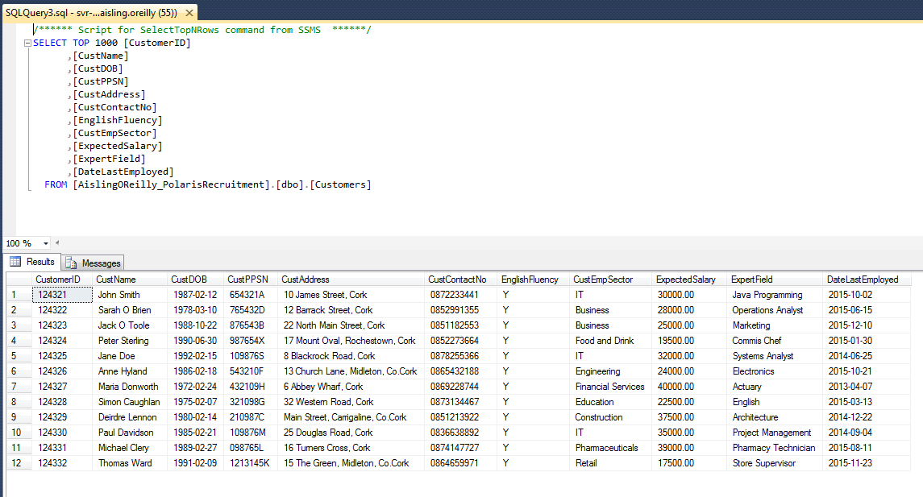

Staff

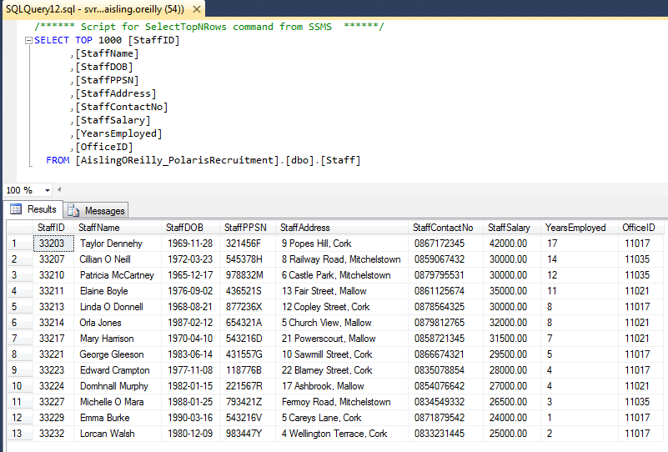

Employers

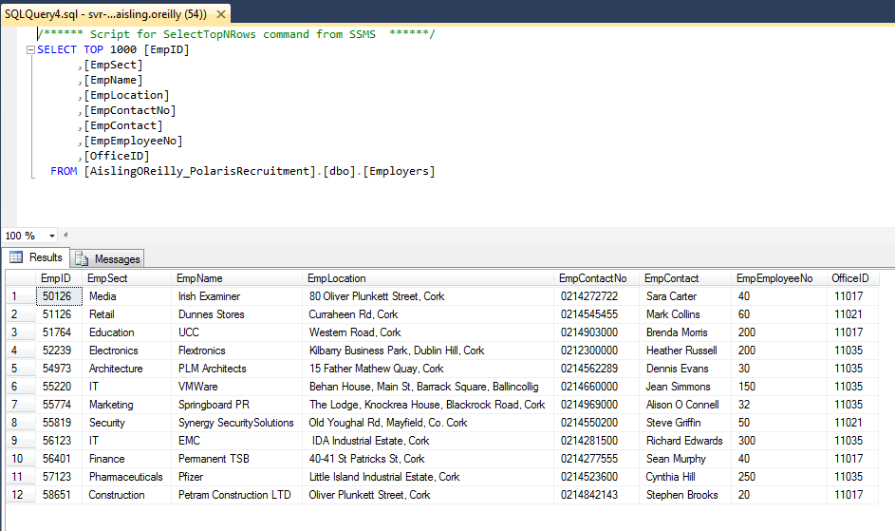

Local Jobs

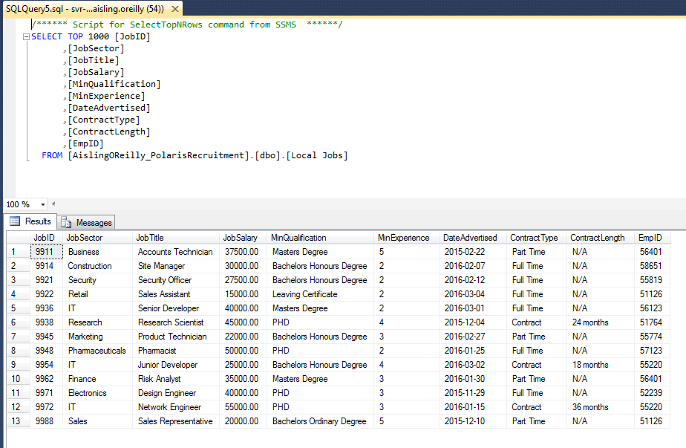

Customer Jobs

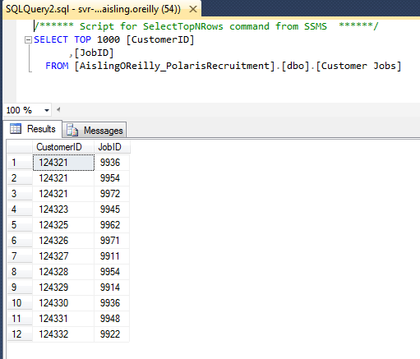

Courses

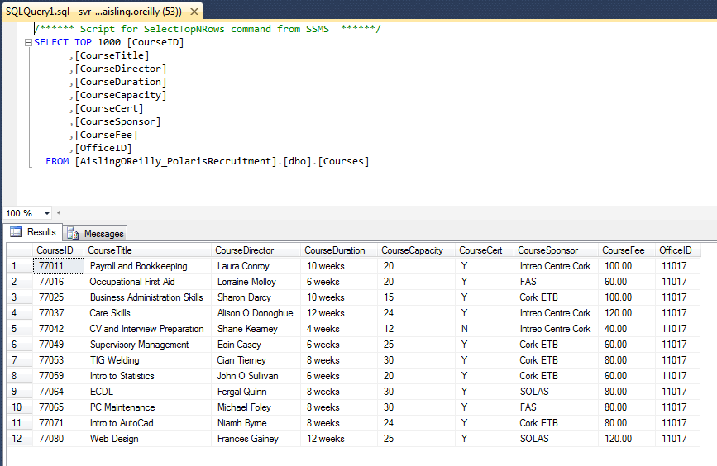

Office

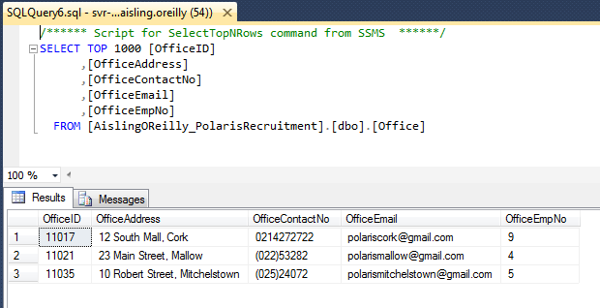

**Design View**

Customers

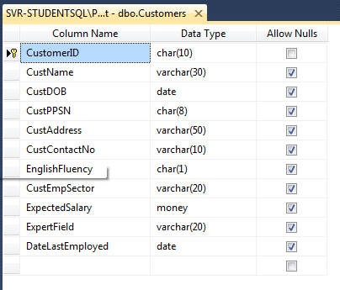

Staff

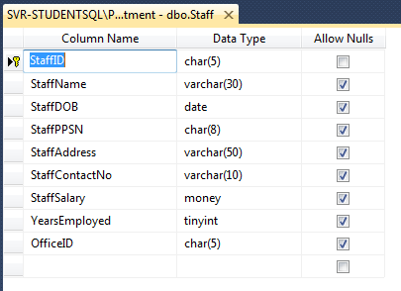

Employers

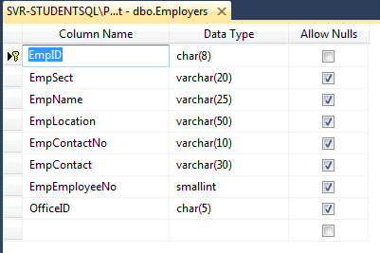

Local Jobs

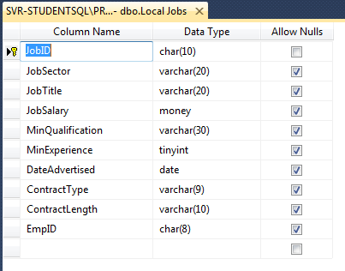

Customer Jobs

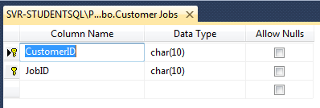

Courses

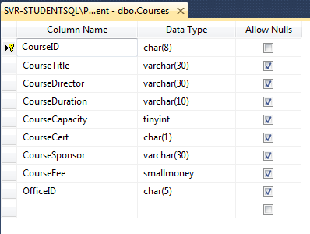

Office

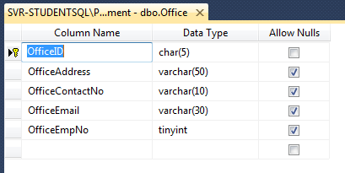

**Database Diagram:**

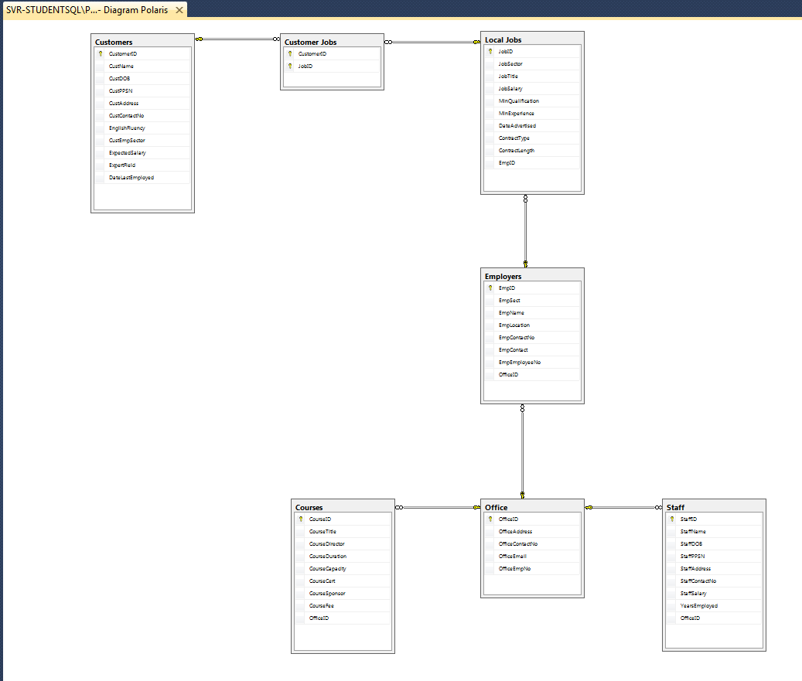

**Queries:**

**Explanation**

1 **- (VIEW) Large Employers:** Return details of employers who employ over 250 staff

2 - **(VIEW) Jobs in IT:** Returns details of Jobs advertised in the IT sector

3 - **(VIEW) Large Starting Salary:** Returns details of jobs with a starting salary of over €45,000

4 - **(VIEW) Customers from Midleton:** Returns details of customers living in Midleton

5 **- (INNER JOIN) Staff Details by Office:** Returns specific details of staff by what office they work in

6 - **(UNION) Compare Expected and Offered Salaries:** Returns the minimum, maximum and average salaries expected by customers and offered by jobs advertised

7 - **(UNION) Select all Employment Sectors:** Returns all employment sectors from the Employers, Jobs and Customers tables

8 - **(STORED PROCEDURE) Get Full Time Jobs:** Returns details of jobs that offer full time employment

9 **- (TRIGGER) Update Employee Number:** Updates the employee number in the office table after a new staff member is added

10 - **(FUNCTION) Get Jobs by Date:** Returns the number of Jobs advertised on a specific date

**SQL Script**

**1 - Large Employers:**

CREATE VIEW [LargeEmployers] AS

SELECT *

FROM Employers

WHERE EmpEmployeeNo > 250

SELECT * FROM [LargeEmployers]

**2 - Jobs in IT:**

CREATE VIEW [**Jobs in IT**] AS

SELECT *

FROM [Local Jobs]

WHERE JobSector = ‘IT’

SELECT * FROM [**Jobs in IT**]

**3 - Large Starting Salary:**

CREATE VIEW [**Large Starting Salary**] AS

SELECT *

FROM [Local Jobs]

WHERE JobSalary > 45000

SELECT * FROM [**Large Starting Salary**]

**4 - Customers from Midleton:**

CREATE VIEW [**Customers from Midleton**] AS

SELECT *

FROM [Customers]

WHERE CustAddress LIKE ‘%**Midleton**%’

SELECT * FROM [**Customers from Midleton**]

**5 - Staff Details by Office:**

SELECT Staff.StaffID, Staff.StaffName, Staff.StaffPPSN, Office.OfficeAddress, Office.OfficeContactNo

FROM Staff

INNER JOIN Office

ON Staff.OfficeID = Office.OfficeID

ORDER BY OfficeAddress

**6 - Compare Expected and Offered Salaries:**

SELECT MIN(JobSalary) AS Minimum, MAX(JobSalary) AS Maximum, AVG(JobSalary) AS Average

FROM [Local Jobs]

UNION

SELECT MIN(ExpectedSalary) AS Minimum, MAX(ExpectedSalary) AS Maximum, AVG(ExpectedSalary) AS Average

FROM [Customers]

**7 - Select all Employment Sectors:**

SELECT EmpSect FROM [Employers]

UNION

SELECT JobSector FROM [Local Jobs]

UNION

SELECT CustEmpSector FROM [Customers]

ORDER BY EmpSect

**8 - Get Full Time Jobs:**

CREATE PROCEDURE spGetFullTimeJobs @Contract varchar(9)

AS

SELECT *

FROM [Local Jobs]

WHERE ContractType = @Contract

EXEC spGetFullTimeJobs 'Full Time'

**9 - Update Employee Number:**

CREATE TRIGGER UpdateEmployeeNo

ON Staff

AFTER INSERT

AS

BEGIN

UPDATE Office

SET OfficeEmpNo = OfficeEmpNo + 1

WHERE Office.OfficeID = (SELECT OfficeID FROM Inserted)

END

**10 - Get Jobs by Date:**

CREATE FUNCTION getNoJobsbyDate(@ADdate date)

RETURNS INT

AS

BEGIN

RETURN (SELECT COUNT (JobID) FROM [Local Jobs] WHERE DateAdvertised = @ADdate)

END

SELECT dbo.getNoJobsbyDate(‘03/04/16’) AS ‘No. of Jobs Advertised on March 4th’

**Result**

**1 - Large Employers:**

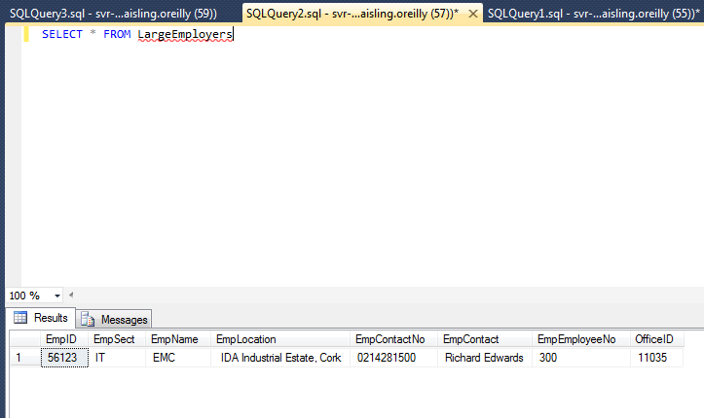

**2 - Jobs in IT:**

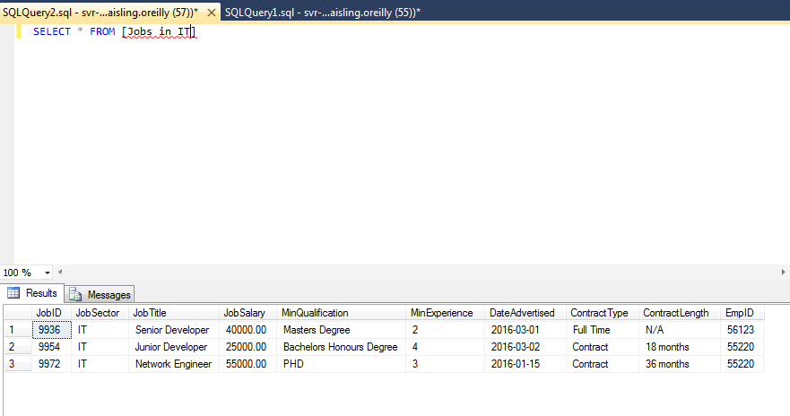

**3 - Large Starting Salary:**

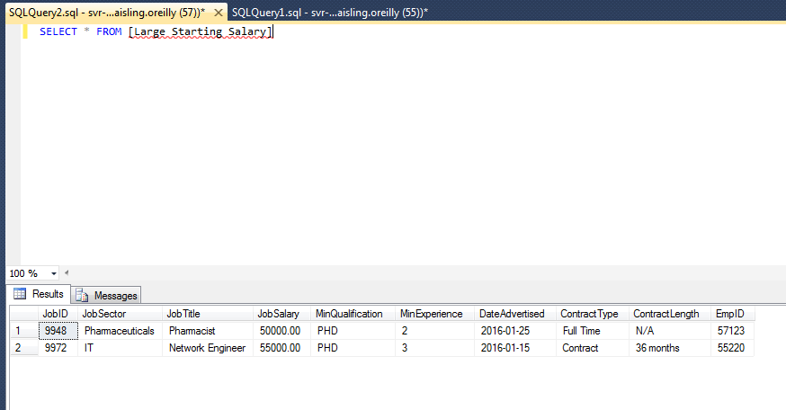

**4 - Customers from Midleton:**

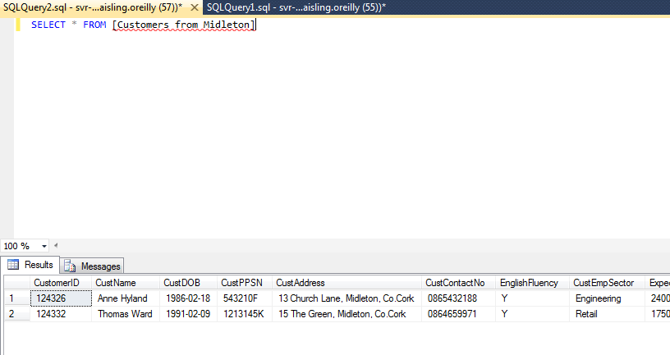

**5 - Staff Details by Office:**

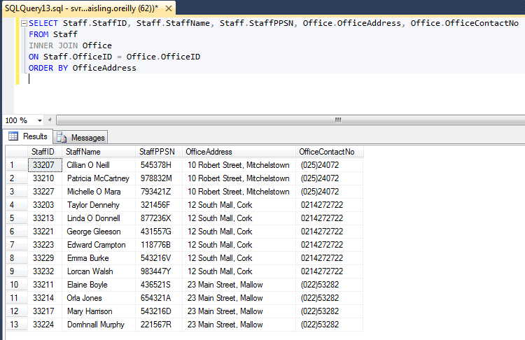

**6 - Compare Expected and Offered Salaries:**

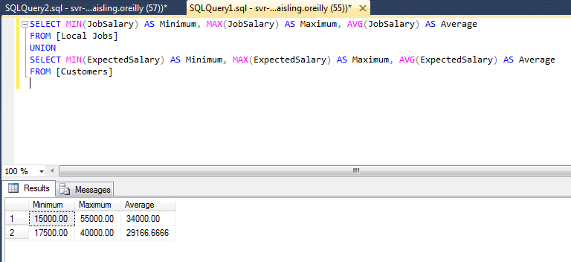

**7 - Select all Employment Sectors:**

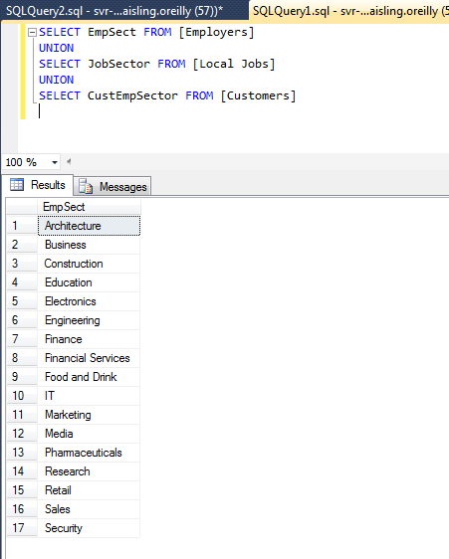

**8 - Get Full Time Jobs:**

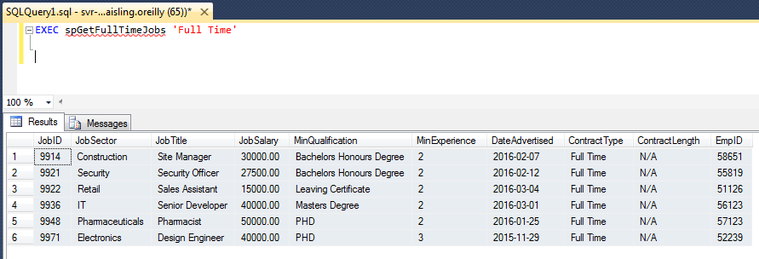

**9 - Update Employee Number:**

Office Employee Numbers before Insert

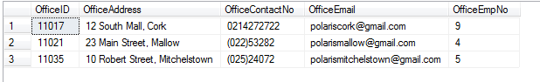

Inserting a new Staff member

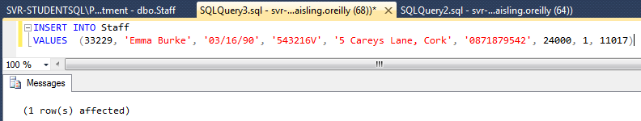

Office Employee Numbers after Insert

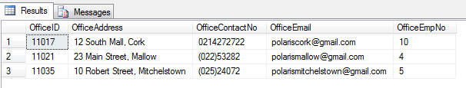

**10 - Get Jobs by Date:**

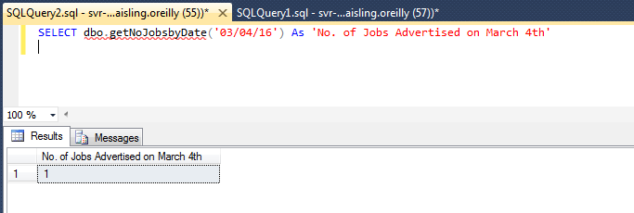

**Visual Basic Project**

**Form Screenshots**

Customers

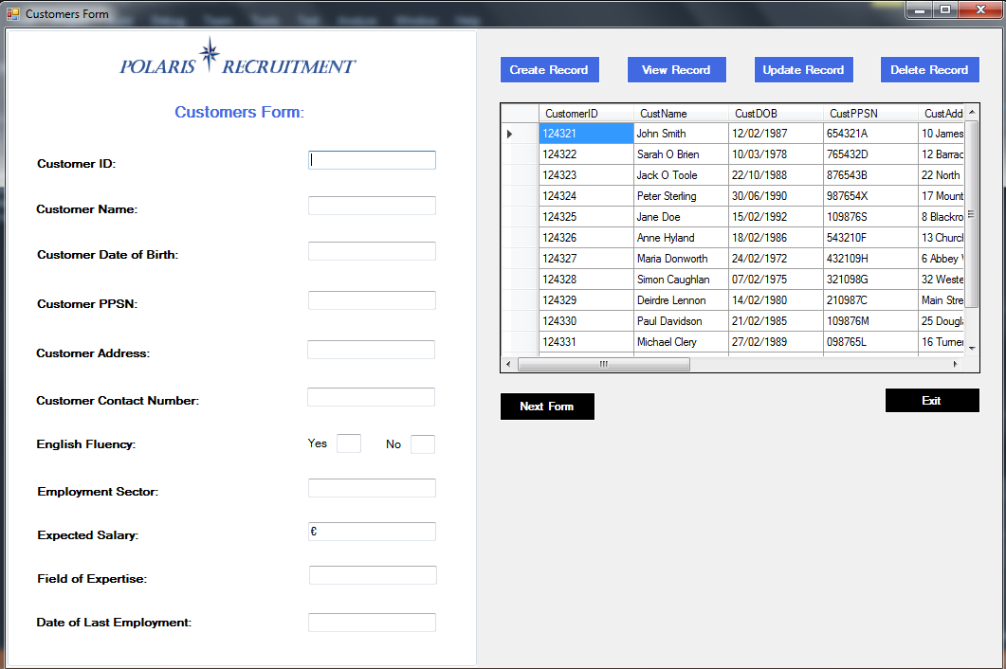

Staff

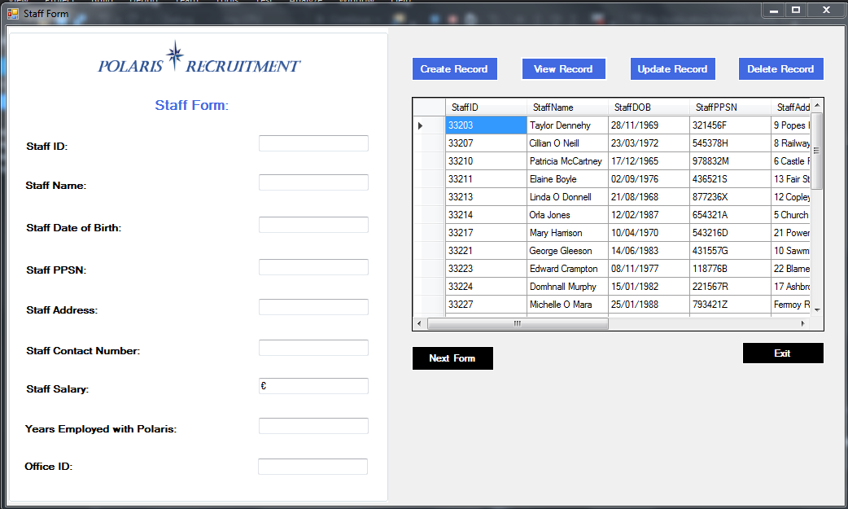

Employers

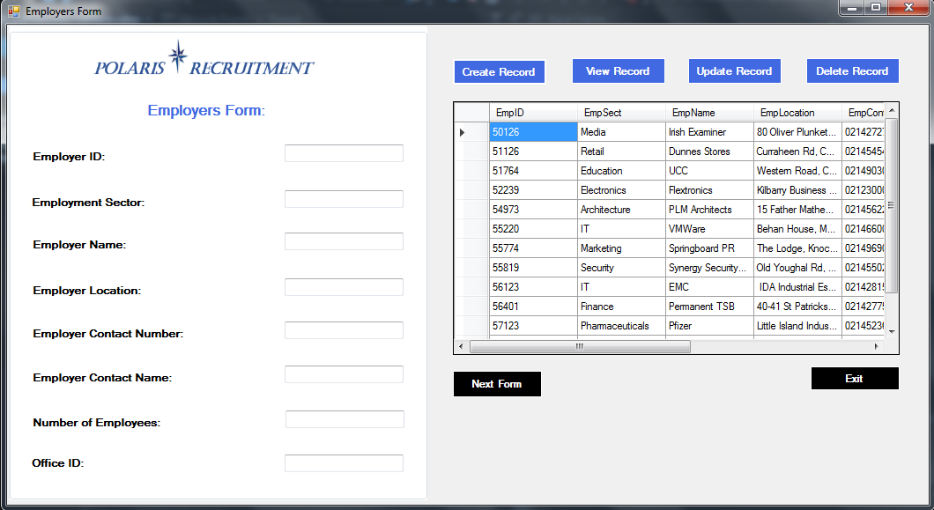

Local Jobs

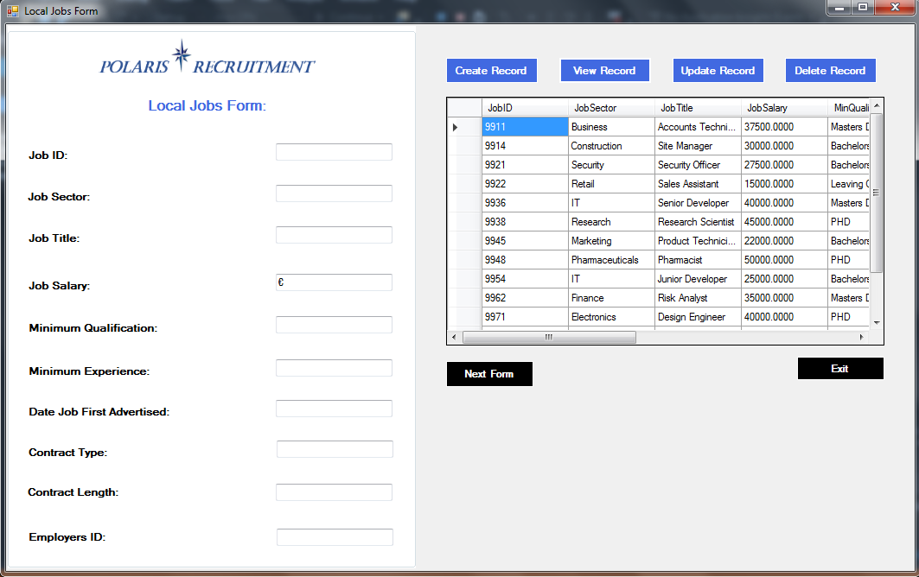

Customer Jobs

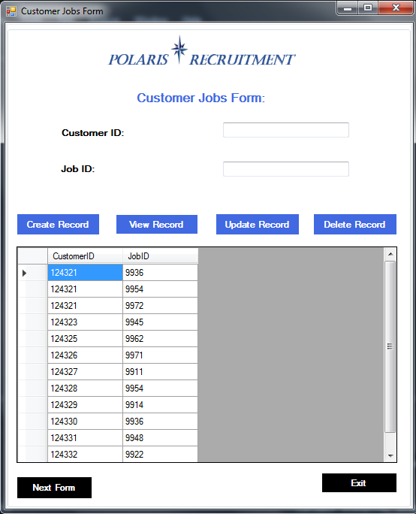

Courses

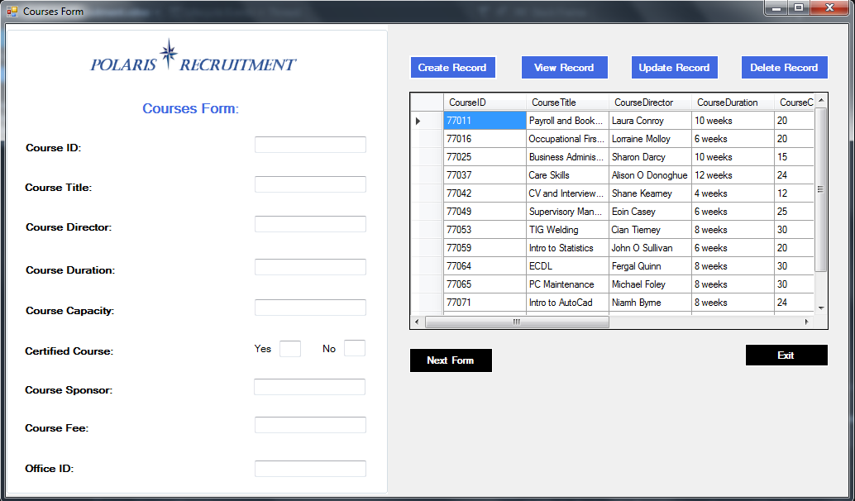

Office

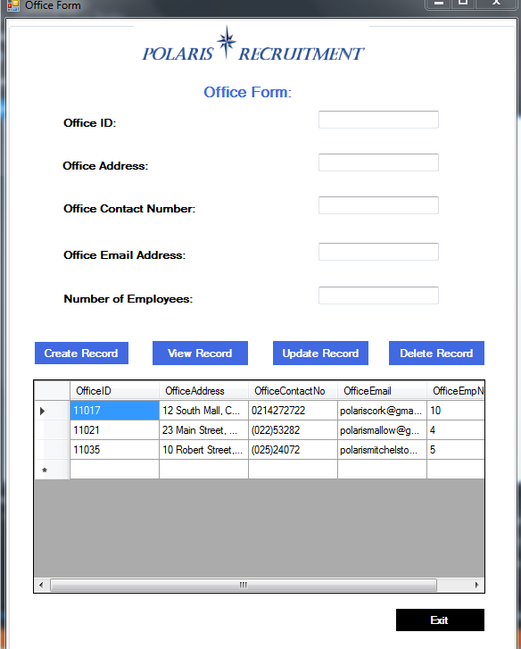

**Form Code**

Customers

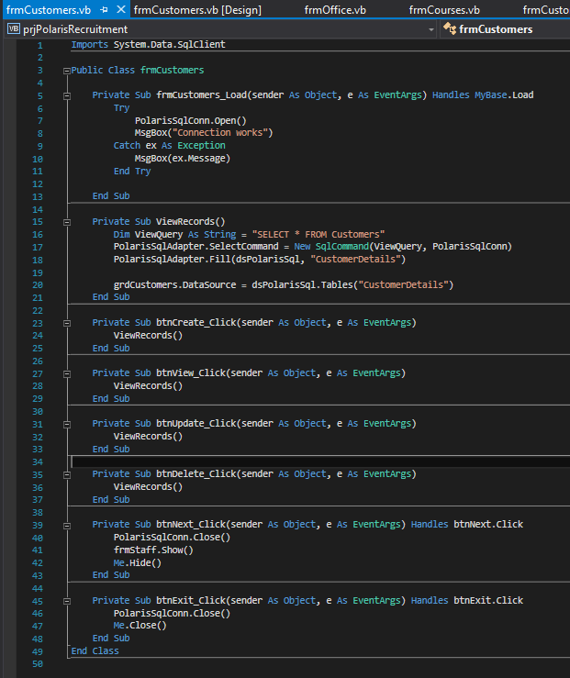

Staff

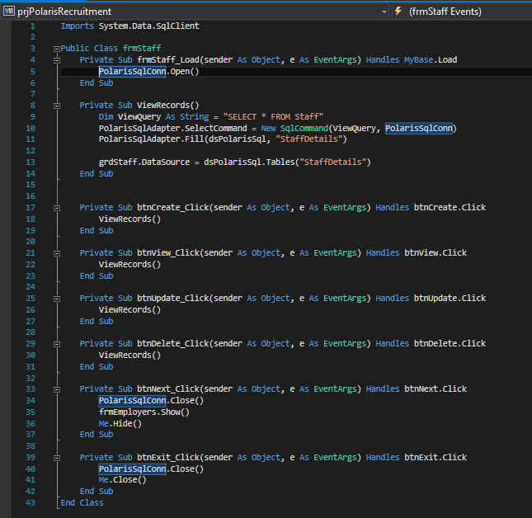

Employers

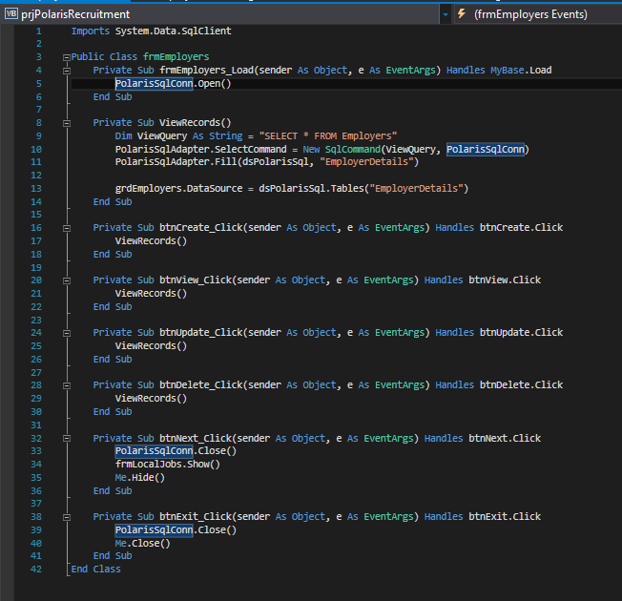

Local Jobs

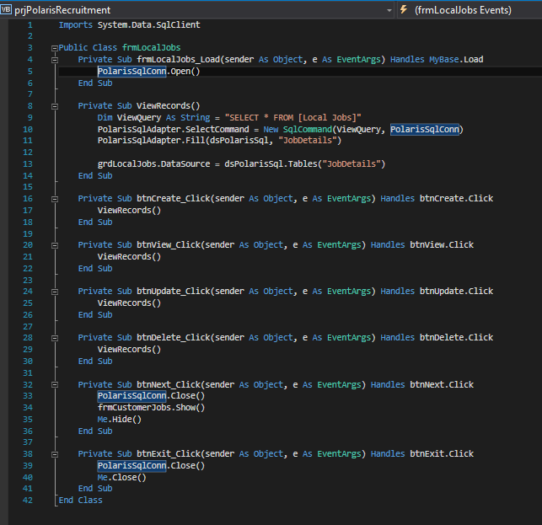

Customer Jobs

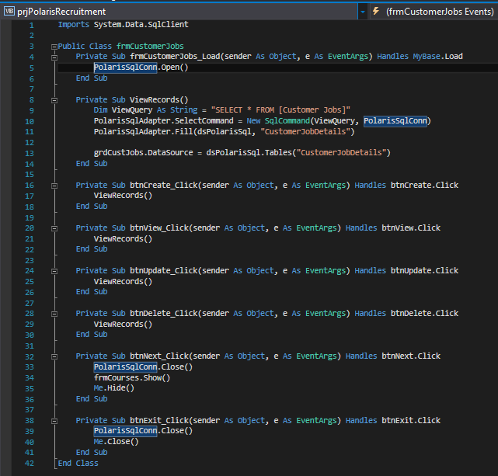

Courses

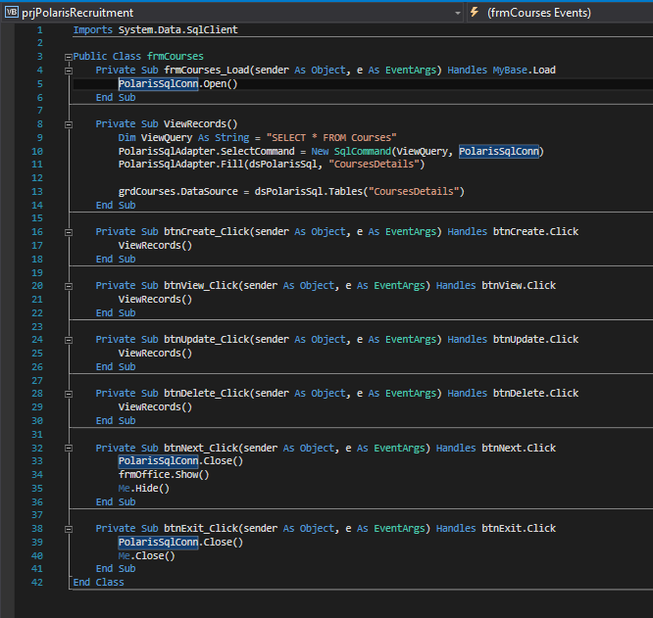

Office

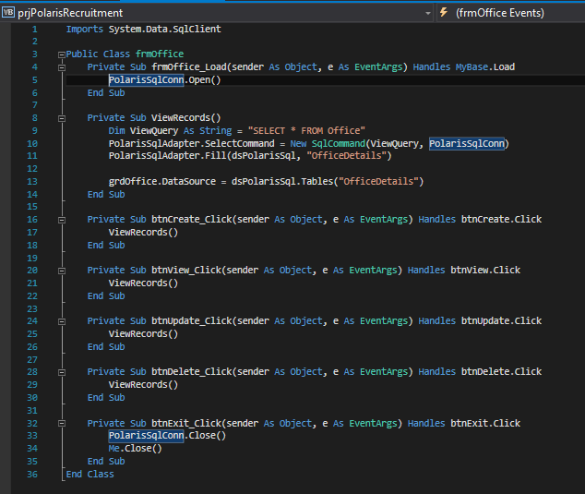

**Test Plan**

**Test Data Used - Insert Scripts**

Customers

INSERT INTO Customers

VALUES (124321, 'John Smith', '02/12/87', '654321A', '10 James Street, Cork', '0872233441', 'Y', 'IT', 30000, 'Java Programming', '10/02/2015'),

(124322, 'Sarah O Brien', '03/10/78', '765432D', '12 Barrack Street, Cork', '0852991355', 'Y', 'Business', 28000, 'Operations Analyst', '06/15/2015'),

(124323, 'Jack O Toole', '10/22/88', '876543B', '22 North Main Street, Cork', '0851182553', 'Y', 'Business', 25000, 'Marketing', '12/10/2015'),

(124324, 'Peter Sterling', '06/30/90', '987654X', '17 Mount Oval, Rochestown, Cork', '0852273664', 'Y', 'Food and Drink', 19500, 'Commis Chef', '01/30/2015'),

(124325, 'Jane Doe', '02/15/92', '109876S', '8 Blackrock Road, Cork', '0878255366', 'Y', 'IT', 32000, 'Systems Analyst', '06/25/2014'),

(124326, 'Anne Hyland', '02/18/86', '543210F', '13 Church Lane, Midleton, Co.Cork', '0865432188', 'Y', 'Engineering', 24000, 'Electronics', '10/21/2015'),

(124327, 'Maria Donworth', '02/24/72', '432109H', '6 Abbey Wharf, Cork', '0869228744', 'Y', 'Financial Services', 40000, 'Actuary', '04/07/2013'),

(124328, 'Simon Caughlan', '02/07/75', '321098G', '32 Western Road, Cork', '0873134467', 'Y', 'Education', 22500, 'English', '03/13/2015'),

(124329, 'Deirdre Lennon', '02/14/80', '210987C', 'Main Street, Carrigaline, Co.Cork', '0851213922', 'Y', 'Construction', 37500, 'Architecture', '12/22/2014'),

(124330, 'Paul Davidson', '02/21/85', '109876M', '25 Douglas Road, Cork', '0836638892', 'Y', 'IT', 35000, 'Project Management', '09/04/2014'),

(124331, 'Michael Clery', '02/27/89', '098765L', '16 Turners Cross, Cork', '0874147727', 'Y', 'Pharmaceuticals', 39000, 'Pharmacy Technician', '08/11/2015'),

(124332, 'Thomas Ward', '02/09/91', '1213145K', '15 The Green, Midleton, Co.Cork', '0864659971', 'Y', 'Retail', 17500, 'Store Supervisor', '11/23/2015')

Staff

INSERT INTO Staff

VALUES (33214, 'Orla Jones', '02/12/87', '654321A', '5 Church View, Mallow', '0879812765', 32000, 8, 11021),

(33217, 'Mary Harrison', '04/10/70', '543216D', '21 Powerscourt, Mallow', '0858721345', 31500, 7, 11021),

(33221, 'George Gleeson', '06/14/83', '431557G', '10 Sawmill Street, Cork', '0866674321', 29500, 5, 11017),

(33210, 'Patricia McCartney', '12/17/65', '978832M', '6 Castle Park, Mitchelstown', '0879795531', 30000, 12, 11035),

(33213, 'Linda O Donnell', '08/21/68', '877236X', '12 Copley Street, Cork', '0878564325', 30000, 8, 11017),

(33207, 'Cillian O Neill', '03/23/72', '545378H', '8 Railway Road, Mitchelstown', '0859067432', 30000, 14, 11035),

(33223, 'Edward Crampton', '11/08/77', '118776B', '22 Blarney Street, Cork', '0835078854', 28000, 4, 11017),

(33232, 'Lorcan Walsh', '12/09/80', '983447Y', '4 Wellington Terrace, Cork', '0833231445', 25000, 2, 11017),

(33224, 'Domhnall Murphy', '01/15/82', '221567R', '17 Ashbrook, Mallow', '0854076642', 27000, 4, 11021),

(33211, 'Elaine Boyle', '09/02/76', '436521S', '13 Fair Street, Mallow', '0861125674', 35000, 11, 11021),

(33203, 'Taylor Dennehy', '11/28/69', '321456F', '9 Popes Hill, Cork', '0867172345', 42000, 17, 11017),

(33227, 'Michelle O Mara', '01/25/88', '793421Z', 'Fermoy Road, Mitchelstown', '0834549332', 26500, 3, 11035

Employers

INSERT INTO Employers

VALUES (55220, 'IT', 'VMWare', 'Behan House, Main St, Barrack Square, Ballincollig', '0214660000', 'Jean Simmons', 150, 11035),

(56401, 'Finance', 'Permanent TSB', '40-41 St Patricks St, Cork', '0214277555', 'Sean Murphy', 40, 11017),

(55774, 'Marketing', 'Springboard PR', 'The Lodge, Knockrea House, Blackrock Road, Cork', '0214969000', 'Alison O Connell', 32, 11035),

(57123, 'Pharmaceuticals', 'Pfizer', 'Little Island Industrial Estate, Cork', '0214523600', 'Cynthia Hill', 250, 11035),

(56123, 'IT', 'EMC', ' IDA Industrial Estate, Cork', '0214281500', 'Richard Edwards', 300, 11035),

(55819, 'Security', 'Synergy SecuritySolutions', 'Old Youghal Rd, Mayfield, Co. Cork', '0214550200', 'Steve Griffin', 50, 11021),

(51126, 'Retail', 'Dunnes Stores', 'Curraheen Rd, Cork', '0214545455', 'Mark Collins', 60, 11021),

(54973, 'Architecture', 'PLM Architects', '15 Father Mathew Quay, Cork', '0214562289', 'Dennis Evans', 30, 11035),

(52239, 'Electronics', 'Flextronics', 'Kilbarry Business Park, Dublin Hill, Cork', '0212300000', 'Heather Russell', 200, 11035),

(58651, 'Construction', 'Petram Construction LTD', 'Oliver Plunkett Street, Cork', '0214842143', 'Stephen Brooks', 20, 11017),

(50126, 'Media', 'Irish Examiner', '80 Oliver Plunkett Street, Cork', '0214272722', 'Sara Carter', 40, 11017),

(51764, 'Education', 'UCC', 'Western Road, Cork', '0214903000', 'Brenda Morris', 200, 11017)

Local Jobs

INSERT INTO [Local Jobs]

VALUES (09954, 'IT', 'Junior Developer', 25000, 'Bachelors Honours Degree', 4, '03/02/16', 'Contract', '18 months', 55220),

(09962, 'Finance', 'Risk Analyst', 35000, 'Masters Degree', 3, '01/30/16', 'Part Time', 'N/A', 56401),

(09914, 'Construction', 'Site Manager', 30000, 'Bachelors Honours Degree', 2, '02/07/16', 'Full Time', 'N/A', 58651),

(09972, 'IT', 'Network Engineer', 55000, 'PHD', 3, '01/15/16', 'Contract', '36 months', 55220),

(09988, 'Sales', 'Sales Representative', 20000, 'Bachelors Ordinary Degree', 5, '12/10/15', 'Part Time', 'N/A', 51126),

(09921, 'Security', 'Security Officer', 27500, 'Bachelors Honours Degree', 2, '02/12/16', 'Full Time', 'N/A', 55819),

(09945, 'Marketing', 'Product Technician', 22000, 'Bachelors Honours Degree', 3, '02/27/16', 'Part Time', 'N/A', 55774),

(09938, 'Research', 'Research Scientist', 45000, 'PHD', 4, '12/04/15', 'Contract', '24 months', 51764),

(09971, 'Electronics', 'Design Engineer', 40000, 'PHD', 3, '11/29/15', 'Full Time', 'N/A', 52239),

(09948, 'Pharmaceuticals', 'Pharmacist', 50000, 'PHD', 2, '01/25/16', 'Full Time', 'N/A', 57123),

(09911, 'Business', 'Accounts Technician', 37500, 'Masters Degree', 5, '02/22/15', 'Part Time', 'N/A', 56401),

(09936, 'IT', 'Senior Developer', 40000, 'Masters Degree', 2, '03/01/16', 'Full Time', 'N/A', 56123),

(09922, 'Retail', 'Sales Assistant', 15000, 'Leaving Certificate', 2, '03/04/16', 'Full Time', 'N/A', 51126)

Customer Jobs

INSERT INTO [Customer Jobs]

VALUES (124321, 09954),

(124321, 09936),

(124325, 09962),

(124327, 09911),

(124326, 09971),

(124330, 09936),

(124331, 09948),

(124332, 09922),

(124323, 09945),

(124328, 09954),

(124321, 09972),

(124329, 09914)

Courses

INSERT INTO Courses

VALUES (77059, 'Intro to Statistics', 'John O Sullivan', '6 weeks', 20, 'Y', 'Cork ETB', 60, 11017),

(77065, 'PC Maintenance', 'Michael Foley', '8 weeks', 30, 'Y', 'FAS', 80, 11017),

(77071, 'Intro to AutoCad', 'Niamh Byrne', '8 weeks', 24, 'Y', 'Cork ETB', 80, 11017),

(77037, 'Care Skills', 'Alison O Donoghue', '12 weeks', 24, 'Y', 'Intreo Centre Cork', 120, 11017),

(77042, 'CV and Interview Preparation', 'Shane Kearney', '4 weeks', 12, 'N', 'Intreo Centre Cork', 40, 11017),

(77016, 'Occupational First Aid', 'Lorraine Molloy', '6 weeks', 20, 'Y', 'FAS', 60, 11017),

(77025, 'Business Administration Skills', 'Sharon Darcy', '10 weeks', 15, 'Y', 'Cork ETB', 100, 11017),

(77064, 'ECDL', 'Fergal Quinn', '8 weeks', 30, 'Y', 'SOLAS', 80, 11017),

(77049, 'Supervisory Management', 'Eoin Casey', '6 weeks', 25, 'Y', 'Cork ETB', 60, 11017),

(77080, 'Web Design', 'Frances Gainey', '12 weeks', 25, 'Y', 'SOLAS', 120, 11017),

(77011, 'Payroll and Bookkeeping', 'Laura Conroy', '10 weeks', 20, 'Y', 'Intreo Centre Cork', 100, 11017),

(77053, 'TIG Welding', 'Cian Tierney', '8 weeks', 30, 'Y', 'Cork ETB', 80, 11017)

Office

INSERT INTO Office

VALUES (11017, '12 South Mall, Cork', '0214272722', 'polariscork@gmail.com', 9),

(11021, '23 Main Street, Mallow', '(022)53282', 'polarismallow@gmail.com', 4),

(11035, '10 Robert Street, Mitchelstown', '(025)24072', 'polarismitchelstown@gmail.com', 5)

**Modifications to Design**

When implementing the queries I had specified in the design phase, it was necessary to change 6 out of the 10 to meet the needs of the brief, particularly the Trigger, Stored Procedure and Function queries.

The 4 original queries outlined in the design phase I used for the views:

* **Large Employers**
* **Jobs in IT**
* **Large Starting Salary**
* **Customers from Midleton**

I modified the ‘**Cork City Staff’** query to the ‘**Staff Details by Office’** for the purpose of an INNER JOIN query

The other 5 queries were created for the purpose of incorporating 2 Union queries, a trigger, a stored procedure and a function. These are outlined as follows:

**• Compare Expected and Offered Salaries - Union**

**• Select all Employment Sectors - Union**

**• Get Full Time Jobs - Stored Procedure**

**• Update Employee Number - Trigger**

**• Get Jobs by Date - Function**

**Conclusion**

During the course of the implementation phase I encountered an oversight on my part regarding the query design. If I had read the brief for the implementation phase thoroughly during the design phase it wouldn't have been neccessary to change as many queries.

While I have a clearer understanding of the concepts of relational databases after the practical applications of the project I would, in hindsight, simplify the design in order to avoid the neccessity of normalisation to the level of 4NF.